Field Definitions – Header

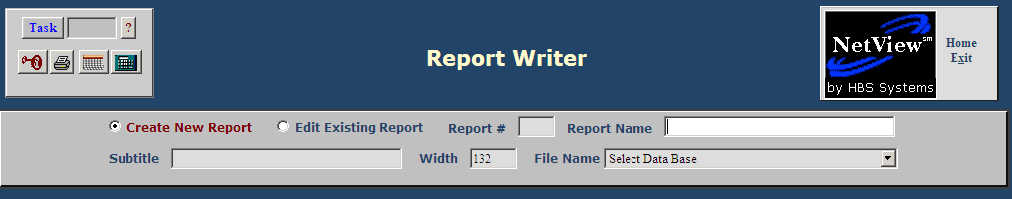

Create New Report/Edit Existing Report: Choose “Create New Report” when starting a new report. Choose “Edit Existing Report” when making changes to a current report.

Editing a Report: When you edit a report, you can access it two ways:

Type the report number in the “Report #” field

Choose the report name from the panel in the middle of the window, where the reports are sorted by package.

Click on the package name at the top of the panel (depicted below) to quickly advance to the reports already available for that package.

Report Number: This is the number for the report created. This field will be filled in by the system when the report is created.

Report Name: When creating a report, give it a specific title by typing a name in this field. The name will appear in the field when you select the report for editing. NOTE: If you give your new report a Report Name that is a duplicate of an existing one, the original file will open and no new report is created.

Subtitle: This field is optional, and can provide an extended description of the report name. It is for informational purposes only. It prints on the report, but does not display on the selection screen for established reports.

Width: The default width of a line is 132 characters. That is the maximum number of characters that can print on one line and is automatically entered by the system. We recommend using the default, though you may change it as necessary to fit the desired information on the report.

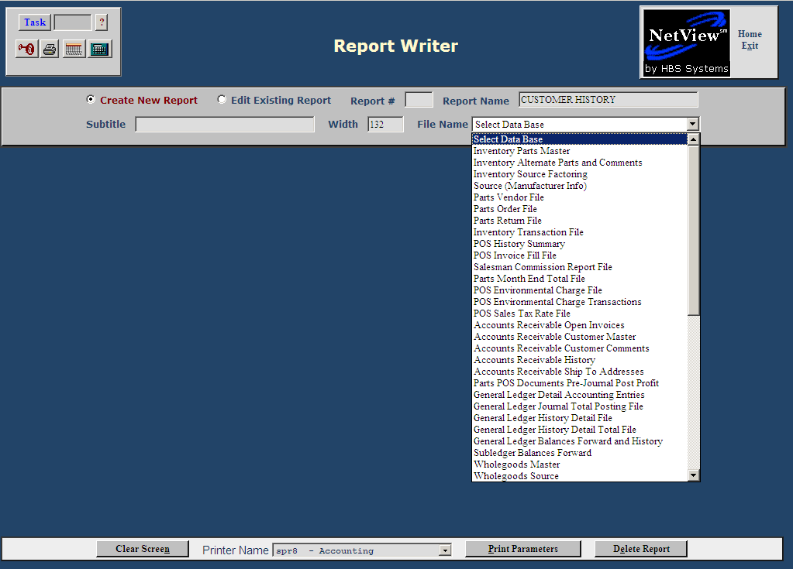

File Name: Here you select the file to generate the report. Use the drop down menu to make your selection. See the topics under “Appendix” for descriptions of the fields in each file.

